Top of Form

Assignment 1 - Blockchain LetsUpgrade

**1)What is Blockchain in your words** ? *

Blockchain technology is a distributed public ledger

that uses the following:

'Proof of work' for maintaining the precise

information

'Hash algorithms' to maintain anonymity

'Incentives' to validate the transactions made

A Blockchain is a constantly growing ledger that keeps permanent record of all the transaction that have taken place in secure,chronological and immutable way in decentralized distributed network

**2)What was the need of Blockchain ? \***

Real-time Tracking

security

transparency

Trusted transaction

no third party involvement

**3)What is Hash do a small demo and upload the photo here ? \***

A hash function takes an input string (numbers, alphabets, media files) of any length and transforms it into a fixed length. The fixed bit length can vary (like 32-bit or 64-bit or 128-bit or 256-bit) depending on the hash function which is being used. The fixed-length output is called a hash. This hash is also the cryptographic byproduct of a hash algorithm

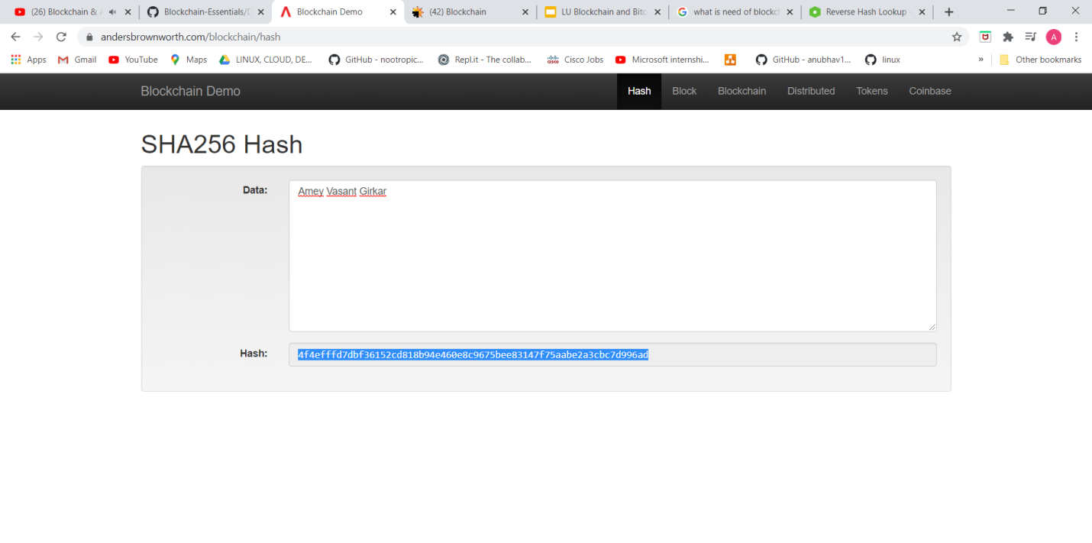

**4)What does a Block Contain \***

**Block contains data and hash value of previous block**



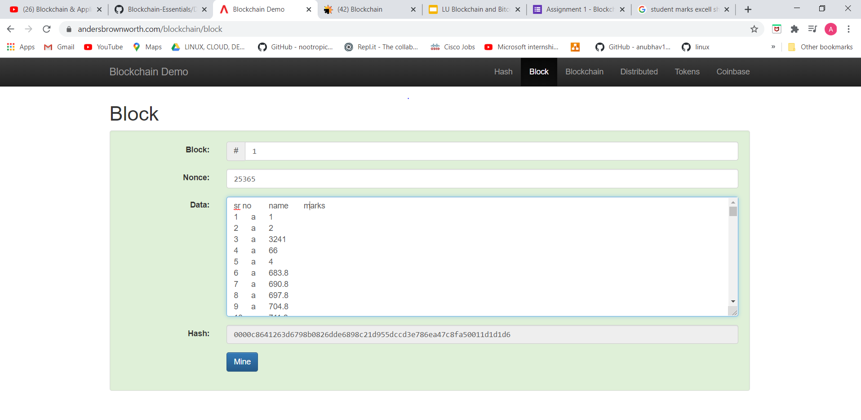

**5)Experiment with Blockchain in real example**

